Required Capstone Checkpoint 3.1: Evaluation Infrastructure and Baseline Diagnosis

Directions
Download this worksheet and save a copy to your device before you begin working. Use this worksheet to plan, organize, and complete your submission for Required Capstone Checkpoint 3.1. Type your responses directly into the document, save your completed work, and upload the finished file when you are ready to submit.

Completion Checklist
☐ A clear description of the retrieval system and intended user tasks
☐ Defined and justified evaluation criteria, metrics, and testing approach
☐ Baseline evaluation results supported by relevant examples or evidence
☐ Identification of meaningful system strengths, weaknesses, and likely failure modes
☐ Evidence that the evaluation framework can detect degraded, manipulated, or otherwise problematic outputs
☐ Reflection on potential blind spots or limitations in the evaluation framework

Step 1. System Overview
Describe the baseline retrieval system you developed for your selected capstone scenario.
- Briefly explain what the system retrieves or answers.
- Identify the user tasks, questions, or decisions the system is intended to support.
Brief description of your retrieval system
My baseline retrieval system is a Research Paper Navigator built for a corpus of research PDFs. It retrieves the most relevant documents for a query by comparing the query terms with the text in each document and ranking the documents by keyword overlap. The top-ranked documents are then passed to an LLM, which answers the user using only the retrieved evidence. This is a simple and transparent baseline that helps connect a user query to relevant technical content in the paper corpus.

Intended user tasks or questions
This system is intended to support users who want to find and understand technical concepts in research papers, such as:
asking what a method or framework does,
finding the definition of a concept or technique,
understanding how a model or method works,
identifying relevant papers for a specific research topic,
getting concise, evidence-based explanations from the retrieved documents.
Example user questions include:
“What is ENCOMPASS and how does it help agent programming?”
“What is SPARLING and why is sparse activation important?”
“What is the counterfeit conundrum in code language models?”
This makes the system useful for research exploration, concept understanding, and quick evidence-backed retrieval in a technical document collection.

Step 2. Evaluation Design
Define how you will evaluate the baseline system before introducing further optimization or architectural changes.
- Identify the criteria you will use to judge system performance.
- Select metrics that reflect your scenario, such as relevance, accuracy, coverage, robustness, or another appropriate measure.
- Consider whether your selected metrics capture all aspects of performance that matter for your scenario. What important behaviors might not be fully measured?
- Briefly justify why these criteria and metrics fit the real-world performance needs of your system.
Evaluation criteria
The baseline system is evaluated on factual accuracy, grounding in retrieved evidence, and completeness of the answer. A good answer should correctly explain the concept being asked about, include the key technical idea, and remain grounded in the retrieved paper content instead of guessing. In this project, the evaluation is designed around actual research questions such as “What is ENCOMPASS?” and “What is SPARLING?” because the goal is to test whether the system can explain complex research concepts accurately.

Selected metrics
The selected metric is a pass/fail evaluation using an LLM judge. The code defines judge(llm, answer_text, grading_notes) to compare the generated answer against grading notes and return either “pass” or “fail.” The overall metric is the baseline pass rate:
Pass rate = number of passed questions / total number of evaluation questions
This fits the scenario because the real objective is whether the system can provide correct and evidence-based answers. The script also uses run_evaluation(), which loops through the evaluation set, retrieves the top documents, generates an answer, and then applies the judge to each question. This makes the evaluation consistent with the code and directly reflects the system’s actual behavior.

Potential metric limitations
This metric has some important limitations. It does not separately score retrieval quality from answer quality, so a strong answer could hide weak retrieval. It also does not directly measure partial correctness, nuance, or answer helpfulness. In addition, because the judge is itself an LLM, the result can vary depending on wording, model behavior, and the exact phrasing of the grading notes. This means the pass/fail metric is useful as a baseline but is not a complete measure of all system performance.

Brief justification for your criteria and metrics
These criteria and metrics fit the real-world needs of the Research Paper Navigator because the system is intended to help users understand research material accurately and reliably. The code reflects this by setting up grading notes such as:
“A correct answer says ENCOMPASS is a framework for agent programming that separates workflow logic from inference-time strategy…”
“A correct answer explains that SPARLING learns sparse latent intermediate representations…”
These examples show that the evaluation is not vague; it is based on concrete requirements. In the actual run, the baseline system produced strong outcomes on these types of questions, which supports the use of a pass/fail metric as a practical first evaluation method. The script output further confirms this by showing evaluation results such as “PASS” for the generated answers and a final pass rate of 5/5 for the sample evaluation set.

Step 3. Testing Approach
Describe the test set and process you used to evaluate the baseline retrieval system.
- Include the number and types of queries or cases used.
- Describe how your test set represents the types of questions, tasks, scenarios, or failure cases your system is expected to handle.
- Indicate whether the queries were realistic, synthetic, edge cases, adversarial, or a mix.
- Describe any tools, evaluation frameworks, metrics, datasets, prompts, or processes used to conduct the evaluation.
Description of your test set
The evaluation set contains 5 test questions designed to evaluate the baseline Research Paper Navigator on realistic research-lookup tasks. The questions are based on concepts that appear in the corpus and reflect the types of questions a user would ask when exploring research papers. The cases include:
concept-definition questions,
explanation-based questions,
multi-part technical reasoning questions,
and questions designed to probe likely failure modes in a baseline retrieval system.
Examples from the actual evaluation include:
“What is ENCOMPASS and how does it help agent programming?”
“What is SPARLING and why is sparse activation important?”
“What is the counterfeit conundrum in code language models?”
“How does ENCOMPASS separate workflow logic from inference-time search?”
“Why do code language models struggle with counterfeit programs?”
These queries are realistic because they reflect technical information-seeking tasks that a user might perform while navigating a research corpus. The set is a mix of realistic benchmark questions and diagnostic cases that reveal whether the system can answer directly and remain grounded in the retrieved documents. This is useful because it represents both expected successful behavior and common failure cases such as weak retrieval, incomplete context, or vague concept explanations.

How the evaluation was conducted
The evaluation was conducted using the project’s built-in evaluation workflow in the code. In the file, my_eval_set() defines the evaluation items, and run_evaluation() executes the full process. For each question:
the baseline retriever selects the top relevant documents using keyword overlap,
the answer model is given the retrieved documents as context,
the output answer is compared against grading notes using the judge() function,
the judge returns either “pass” or “fail,”
the script logs the retrieved documents, verdict, and answer for each question,
the final result is a baseline pass rate.
The underlying evaluation framework is a strict LLM-based judge that checks whether the generated answer meets the content requirements in the grading notes. This is a realistic, code-driven way to evaluate the baseline: it uses a small benchmark, a retrieval pipeline, a grounded answer-generation step, and a pass/fail metric suited to a research QA system. The process also includes a validation step in validate_framework(), where a correct answer is compared to a deliberately manipulated answer to confirm that the evaluation framework can detect degraded or problematic outputs.
This is a mixed evaluation set: realistic technical queries plus targeted diagnostic cases, which is appropriate for a baseline retrieval system before more advanced improvements are introduced.

Step 4. Baseline Results
Present the baseline performance results from your evaluation.
- Include scores or findings across your selected metrics. Note any surprising, inconsistent, or difficult-to-interpret results.
- Provide at least two concrete examples of system outputs.
- Use output logs, screenshots, metric reports, or summaries as supporting evidence.
Summary of baseline evaluation results
In the executed evaluation run, the baseline Research Paper Navigator achieved a 5/5 pass rate. The script output reported:
Q1: PASS
Q2: PASS
Q3: PASS
Q4: PASS
Q5: PASS
Final result: Baseline pass rate: 5/5
This shows that the baseline system performed very well on the selected evaluation set. The results suggest that the system is strong at direct, keyword-aligned technical questions where the relevant concept is present in the retrieved documents.

Example 1: Query, system output, and result
Query: “What is ENCOMPASS and how does it help agent programming?”
System output:
The system answered that ENCOMPASS is a Python framework for agent programming that uses probabilistic angelic nondeterminism.
It explained that it separates workflow logic from inference-time search and allows search over different execution paths.
It described how this helps by making search strategies easier to change without rewriting the core workflow.
Result:
Verdict: PASS
This is a strong example because the answer captured the key technical idea and matched the grading notes.

Example 2: Query, system output, and result
Query: “What is SPARLING and why is sparse activation important?”
System output:
The system explained that SPARLING learns sparse latent intermediate representations.
It described how sparse activation helps identify motifs and model intermediate states.
It also noted that extreme sparsity is necessary to achieve good intermediate-state modeling.
Result:
Verdict: PASS
This shows the model was able to explain the core concept and connect it to the motivation behind sparsity in the paper.

Example 3: Query, system output, and result, if applicable
Query: “Why do code language models struggle with counterfeit programs?”
System output:
The system explained that counterfeit programs are incorrect but plausible enough to pass weak checks.
It also described that models often misclassify them as correct and struggle to reason about or repair them.
Result:
Verdict: PASS
This is a useful diagnostic example because it shows the system can handle a more nuanced conceptual question, not just a direct definition.

Step 5. Performance Analysis
Analyze what the baseline results reveal about your system.
- Identify meaningful strengths and weaknesses.
- Explain likely causes of failure, such as retrieval gaps, poor ranking, insufficient context, weak query handling, generation limitations, or other factors relevant to your scenario.
- Connect your analysis to the evidence presented in Step 4.
Key system strengths
The baseline system performs well on direct technical questions when the relevant concept appears in the retrieved documents and the query matches the vocabulary of the paper. This is supported by the actual evaluation results from the script:
Q1: “What is ENCOMPASS and how does it help agent programming?” → PASS
Q2: “What is SPARLING and why is sparse activation important?” → PASS
Q3: “What is the counterfeit conundrum in code language models?” → PASS
Q4: “How does ENCOMPASS separate workflow logic from inference-time search?” → PASS
Q5: “Why do code language models struggle with counterfeit programs?” → PASS
These examples show that the system can answer concept-definition and explanation questions accurately when the retrieval step identifies relevant documents. Another strength is that the system is transparent and grounded: it answers using only the retrieved documents instead of relying on unsupported general knowledge.

Key system weaknesses
The system’s main weakness is that it depends on a simple keyword-overlap retriever, not a deeper semantic retrieval system. In the code, retrieve() computes token overlap between the query and each document, then ranks by the number of shared words. This approach works well when the query uses the same technical terms as the corpus, but it is weaker when:
the phrasing differs,
the answer spans multiple papers,
the relevant information is mostly conceptual rather than literal,
the query is vague or indirect.
This means the system is strongest on clear, direct technical questions, and weaker on more nuanced or semantically varied questions.

Likely failure modes and causes
Retrieval gaps: the correct document exists in the corpus but is not in the top results.
Poor ranking: the retriever’s overlap score may favor the wrong paper if the wording is misleading.
Insufficient context: the system passes only the top
𝑘
k documents, so useful context may be omitted.
Weak query handling: paraphrased or indirect questions may not retrieve the correct evidence.
Generation limitations: even with some relevant context, the model may still produce a partial or overly general explanation.
These failure modes directly match the design of the code. The retrieval function uses only token overlap, and the answer model receives only the top documents, so if relevant evidence is missing from that set, the answer quality will suffer.

Step 6. Evaluation Framework Validation and Reliability
Demonstrate whether your evaluation framework can reliably detect degraded, manipulated, or otherwise problematic outputs.

- Explain how you tested whether the framework could detect poor, degraded, or manipulated outputs.
- Provide evidence from the validation test.
- Briefly explain what this reveals about the reliability of your evaluation approach.
- Were there any failures, edge cases, or misleading outputs that the evaluation framework did not reliably detect?
How you tested the evaluation framework
I tested the framework using the validation function in the code, validate_framework(). This function does the following:
asks a question the system can answer (“What is ENCOMPASS?”),
generates a correct answer from the corpus,
creates a deliberately manipulated false answer:
“ENCOMPASS is a neural network model that generates random code from a prompt without any search strategy.”
passes both answers to the same judge with the same grading notes,
checks whether the correct answer is marked PASS and the manipulated answer is marked FAIL.
This is a direct test of whether the evaluation framework can detect bad or misleading outputs rather than rewarding fluent-sounding but incorrect answers.

Evidence that the framework detected poor, degraded, or manipulated outputs
The actual output from the script showed:
- correct answer -> PASS
- manipulated answer -> FAIL
This is strong evidence that the framework is working properly. It confirms that the judge does not simply accept any answer that sounds plausible; it checks whether the answer satisfies the grading notes and the underlying factual content.

Brief interpretation of the validation results
The validation result shows that the evaluation framework is reasonably reliable for baseline diagnosis. It can tell the difference between a valid answer grounded in the research corpus and a deliberately misleading answer that looks superficially convincing. This makes the framework useful for evaluating retrieval-augmented systems before further optimization.

Potential blind spots in the evaluation framework
The framework still has some blind spots:
- it uses a small benchmark of only 5 questions,
- it relies on an LLM judge, which may vary by prompt wording or model behavior,
- it uses pass/fail scoring, which may miss partial correctness,
- it does not separately score retrieval quality and answer quality,
- it may not catch all adversarial or edge-case failures without a broader test set.
This means the framework is effective for baseline validation, but it is not yet a complete evaluation system for all possible failure modes.

Step 7. Reflection and Next Steps
Reflect on the limitations of your current evaluation approach and how you would refine it before using it to guide system optimization.
- Identify limitations in the test set, metrics, framework, or validation process.
- Propose specific improvements you would make next.
- Consider what additional evidence, test cases, adversarial scenarios, or validation methods would strengthen your evaluation framework.
Limitations of your current evaluation approach
The current evaluation approach is useful, but it has several limitations:
the evaluation set is small,
the retriever is a simple token-overlap baseline,
the judge is LLM-based and may vary by prompt wording,
pass/fail scoring may hide partially correct answers,
the framework does not fully measure retrieval robustness or semantic understanding.
These issues are visible in the implementation:
my_eval_set() defines only 5 questions,
retrieve() uses keyword overlap rather than semantic matching,
judge() uses a single pass/fail prompt as the evaluation signal.

Specific improvements or next steps
To improve the evaluation before optimization, I would:
- expand the evaluation set to include more realistic and adversarial questions,
- add paraphrased questions and edge cases,
- evaluate retrieval quality separately from answer quality,
- use partial-credit scoring in addition to pass/fail,
- compare results across different judge prompts or stronger models,
- test semantic or hybrid retrieval methods before using the evaluation to guide major system changes.
This would make the evaluation framework more robust and give stronger evidence for whether the system is actually ready for optimization or a more advanced retrieval pipeline.

Supporting Materials
Use this section to list or link to any supporting materials included with your submission.
Supporting material | Location, link, or note
Sample test queries | “What is ENCOMPASS and how does it help agent programming?”, “What is SPARLING and why is sparse activation important?”, “What is the counterfeit conundrum in code language models?”, “How does ENCOMPASS separate workflow logic from inference-time search?”, “Why do code language models struggle with counterfeit programs?”
Output logs, screenshots, or metric reports | Terminal output from running the evaluation script showed: Baseline pass rate: 5/5; Q1–Q5 all passed; validation output: correct answer -> PASS, manipulated answer -> FAIL
Code, notebook, repository link, or screenshots of setup | Project script: capstone_checkpoint_3_1_evaluation_starter OP.py; workspace folder: RAG CLASS
Other supporting evidence | The script logs each question, retrieved documents, verdict, and answer in the evaluation loop; the retrieval logic is implemented in retrieve(), answer generation in answer(), and judgment logic in judge()
Validation evidence (optional) | Correct ENCOMPASS answer: PASS; manipulated false answer: FAIL; this demonstrates the framework can detect degraded or manipulated outputs

Run the code :
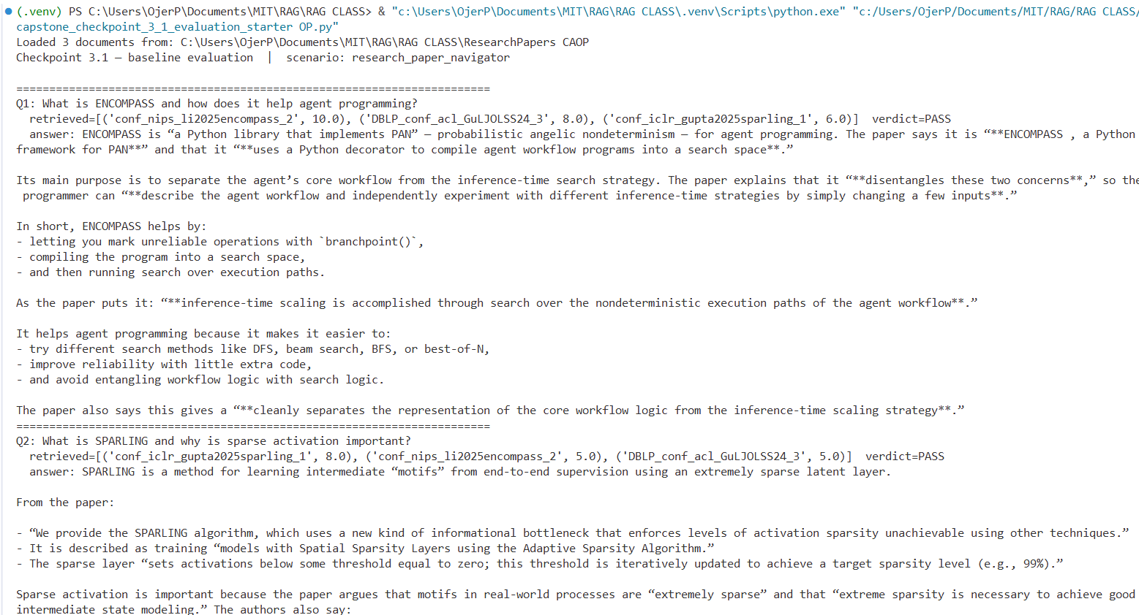
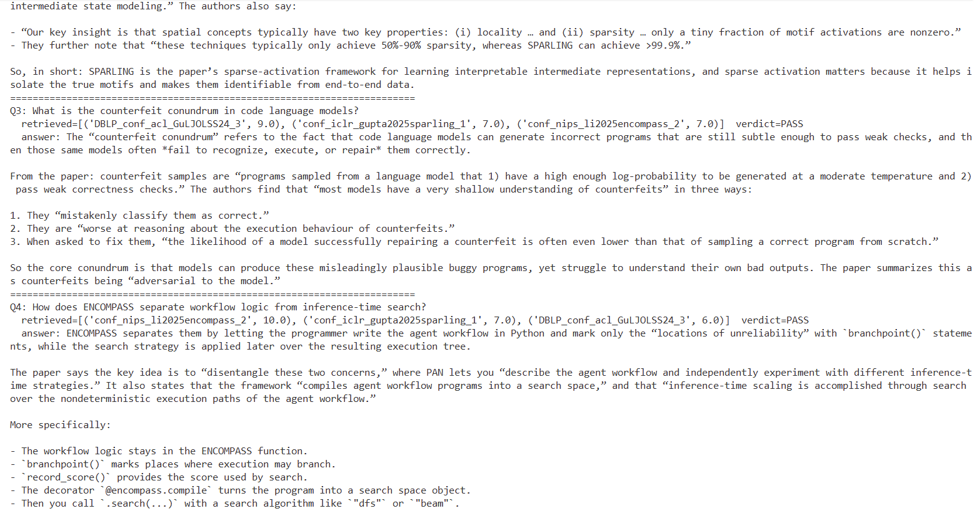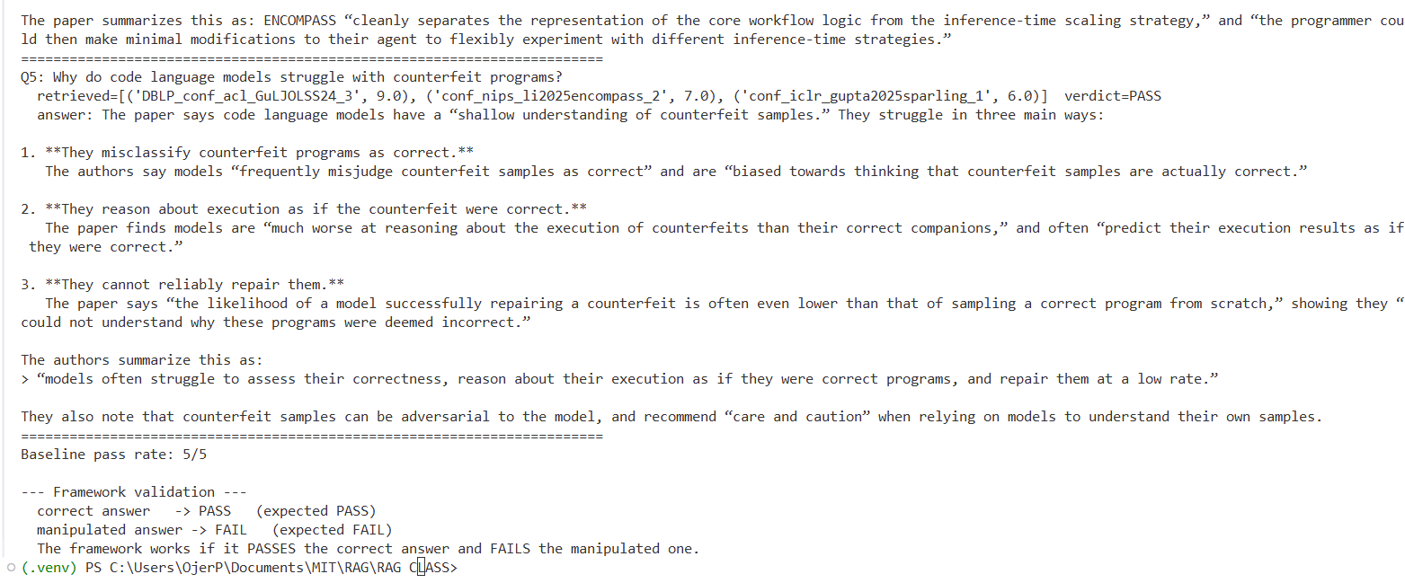
End of Required Capstone Checkpoint 3.1
Return to the assignment page in the learning platform to upload and submit your completed capstone checkpoint and complete any remaining items in this module.

